A/B Test for “On the ROAD”

To define what elements on the website will influence conversion rate of the main goal “成功Sign Up” when users are visiting “On the ROAD”, an “A/B” test is conducted from Dec 4th to Dec 7th.

The homepage is redesigned by changing font style of the heading and contents on the “Sign Up” button, as shown in the two pictures below.

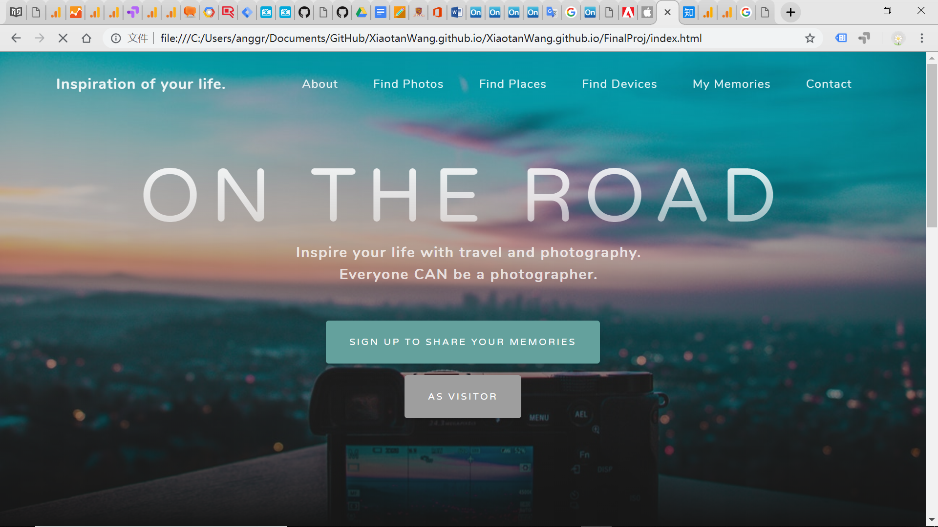

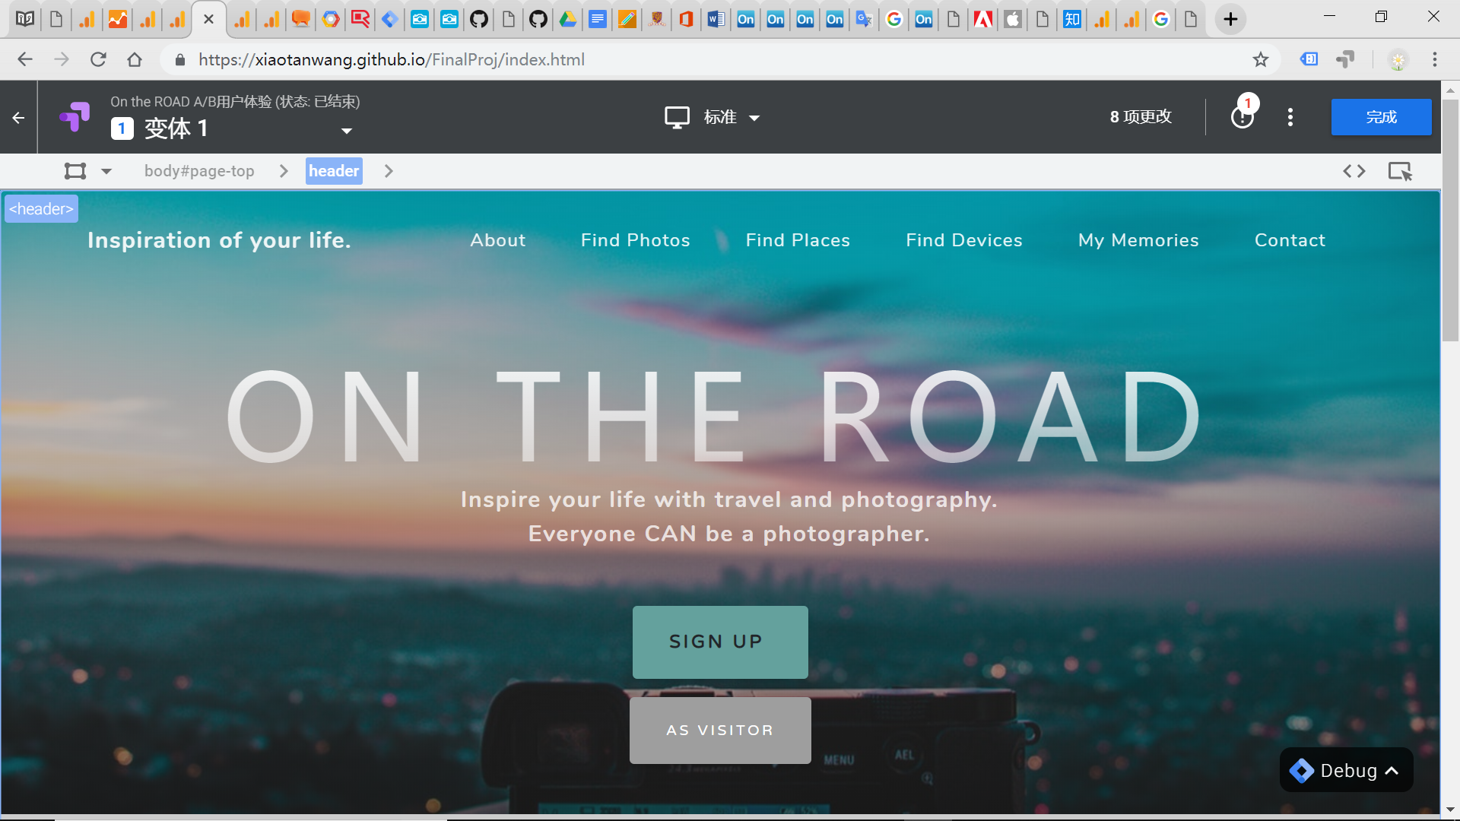

*Figure 1: The original design of “Homepage” and Variant 1*

The A/B Test continued from Dec 4th to Dec 7th, generating up to 201 sessions in total. To directly generate the conclusion, the comparasion of conversion rate of the goal “成功Sign Up” with the total experiment sessions is applied.

In the comparasion, as shown in the line chart below, the conversion rate of the goal was changing everyday. At start, the conversion rate of variant 1 is much higher than that of the original website. However, it kept going down and reached the bottom on Dec 6th and the original website showed much better performance. While on Dec 7th, the concersion rate on the variant 1 went up again.

In conclusion, the total conversion rate of Variant 1 is higher than that of the original website. It indicates that when the “Sign Up” button is more obvious and less ambigurous in contents, the more people will click the button and complete the sign-up function.

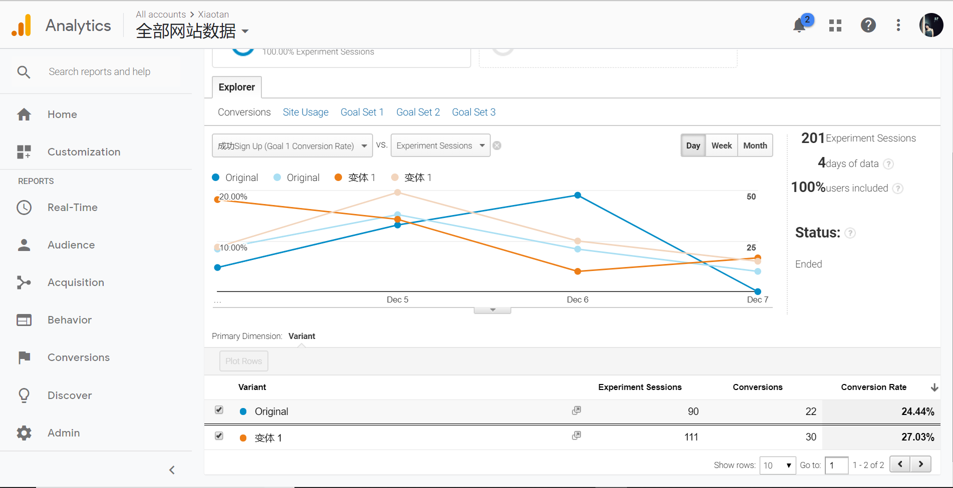

*Figure 21: The analytics of A/B Test*